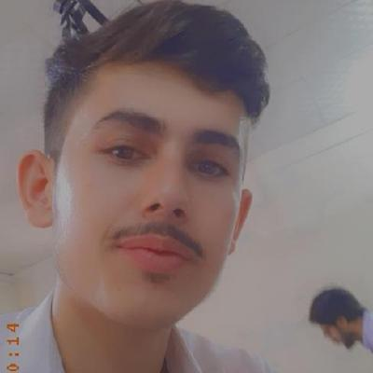

Objectives

- To become a part of professional and well equipped organization.
- To utilize and explore my knowledge (skill in abilities and contribute in organization development accordingly).
- To work in challenging environment with the view of refining my knowledge through practical experience of what I have learned and seeking a long term career oriented relationship with the organization.

Languages / Communication Skills

Language | Speaking | Writing | Reading
English | Good | Good | Excellent
Urdu | Excellent | Excellent | Excellent
Pashto | Excellent | Excellent | Excellent

Skills

Web Development

Wordpress
Experience:
- 1 years experience

Personal Data

Name | Muhammad Junaid
Father name | Muhammad Rafiq
Nationality | PAKISTANI
Religion | ISLAM
Date of birth | 21 MAR 2001
Domicile | Peshawar
Permanent address | Village kochian P/O gulbela. Tehsil & district Peshawar
Present address | Village kochian P/O gulbela. Tehsil & district Peshawar
Mobile No | 03189171479  03079003011
CNIC | 17301-6416627-7

Academic Record

 | Board/university |  | year | division | marks | %age
MATRIC  science |  | B.I.S.E Peshawar | 2017 | 1st | 805/1100 | 73.18%
F.SC  science |  | B.I.S.E Peshawar | 2019 | 1st | 693/1100 | 63%
BSCS 6th semester |  | BKUC | 2022 | 1st | 3.80 CGPA | 86.22%

Curriculum vtae

73.18%

